**Personal & Professional Development**

**2010/2011**

Enter your full Name here

Enter your Student ID here

Enter your Student Email here

**Identifying the value continual personal and professional development brings to individuals and organisations.**

Assignment 2 - Short Formal Report

Submitted 28th November 2010



I hereby certify that this material, which I now submit for assessment is entirely my own work. It has not been taken from the work of others save and to the extent that such work has been citied and acknowledged within the text of my work.

Signed: ………………………………

Date:

Student Number:

**Table of Contents**

Abstract/Summary 4

1. Introduction 5

1.1. Literature Review 6

2. Results 7

3. Discussion 9

4. Conclusions 10

5. Recommendations 11

References 12

Appendices 13

# Abstract/Summary

This should be a short paragraph summarising the main contents of the report. It should include a short statement of the main task, the methods used, conclusions reached and any recommendations to be made. The abstract or summary should be concise, informative and independent of the report. Write this section last, after you have written the main body of the report.

# Introduction

This should give the context and scope of the report and should include your terms of reference (what have you been asked to find out?). State your objectives clearly, define the scope or limits of the report, outline the method of enquiry (literature review only), give a brief general background to the subject of the report and indicate the proposed development.

Your report should be structured as shown in this template, however, titles of sub headings can be added as appropriate in order to structure sections. Print on one side of the paper only (this will be the right hand side when the pages are stapled together).

## Literature Review

This should summarise approximately 10 relevant articles (journal papers, books, newspapers, web references etc.) in the area in question. This section is meant to demonstrate your knowledge of current research activity. Within this section you may include diagrams, tables or figures.

# Results

This section should present what you have found from undertaking your literature review. Present these findings in as simple a way as possible. The more complicated the information looks, the more difficult it will be to interpret. Feel free to use graphs, charts or diagrams to help your reader identify key results. This also helps to break up the text into bite sized pieces. Remember, tables have their caption above the table and need to be cross references in the text i.e. (see 6) should be written within the body of the text.

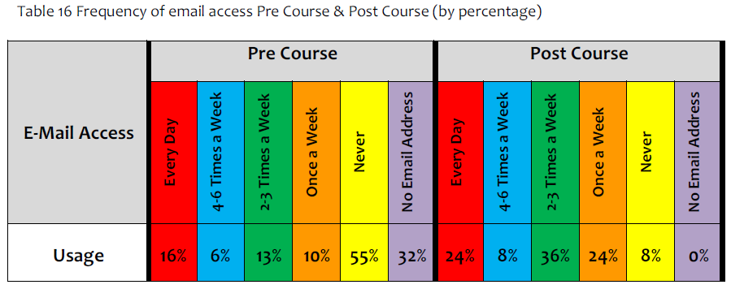

Figures have their caption below the figure as shown.

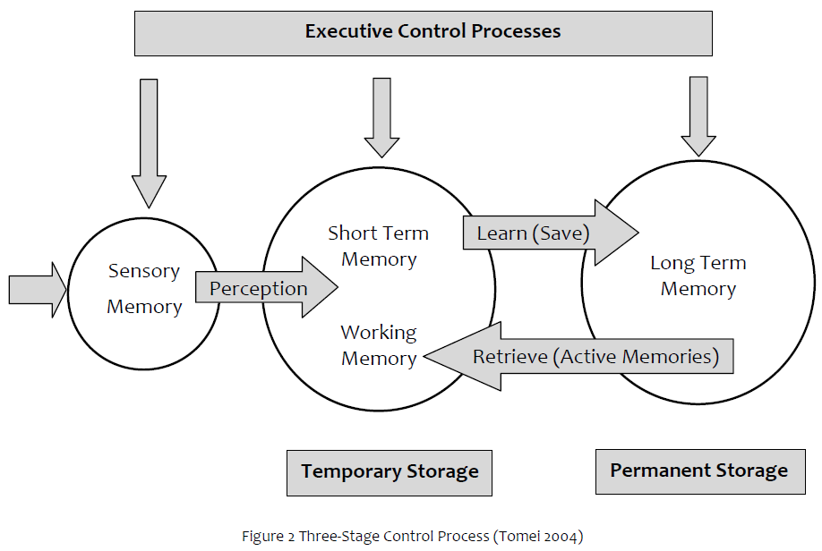

Ensure that if you use colour, the table or figure is still readable in the printed version of your report if printed in black & white.

# Discussion

This is the section where you can analyse and interpret your results, drawing from the information that you have collected and explaining its significance. Identify important issues and suggest explanations for your findings. Outline any problems or barriers and try and present a balanced view.

# Conclusions

Within this section, the findings of all of your research are drawn together and presented. It is an opportunity for you to express your own views or opinion based on the well grounded research you have carried out.

It is essential to remember, any views or opinions outlined within this section should be supported by the evidence within your literature review. No new information should be presented within the conclusion. Try to present a balanced view during your conclusion.

See notes in Moodle for further details of drawing conclusions.

# Recommendations

Within this section you should seek to answer the following questions...

* What do you want the reader to do?
* What action(s) should be taken?
* How can any such action(s) be carried out?
* Who should be responsible for taking action(s)?
* When should any action(s) occur?

Base any recommendations on the conclusions you have drawn.

* Keep them simple.
* Use a list for emphasis, particularly if there are more than two recommendations.
* Consider the tone of your writing... use words like “should”, “recommend” etc.

# References

For this assignment use the Harvard Referencing Style. Ensure you...

* List all references alphabetically.
* Include all the necessary information for locating each reference.
* Check your references are accurate.

Example of the Harvard citation style can be found at the following web link...

<http://www.canberra.edu.au/library/attachments/pdf/harvard.pdf>

# Appendices

This section is optional for your assignment report.

An appendix contains additional information related to the report but which is not essential to the main findings. This can be consulted if the reader wishes, but the report should not depend on this. You could include details of interviews, a glossary of terms, or other information which may be useful for the reader.